Bugs Report
Bug: Product API allows creating a product without title and price
- Description: When I create a new product via Postman and either leave the name or price field empty or remove it completely from the JSON body, the system still creates the product successfully and returns a 201 Created status.
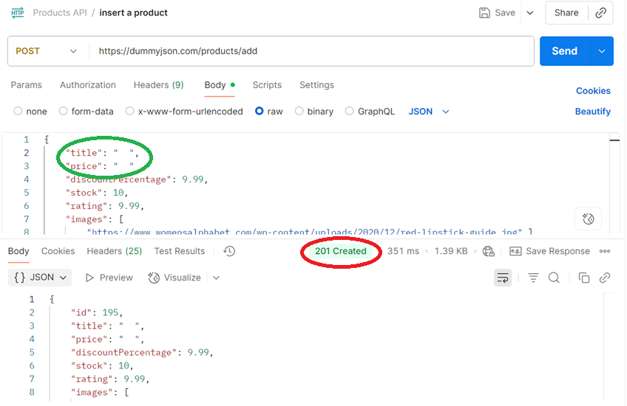
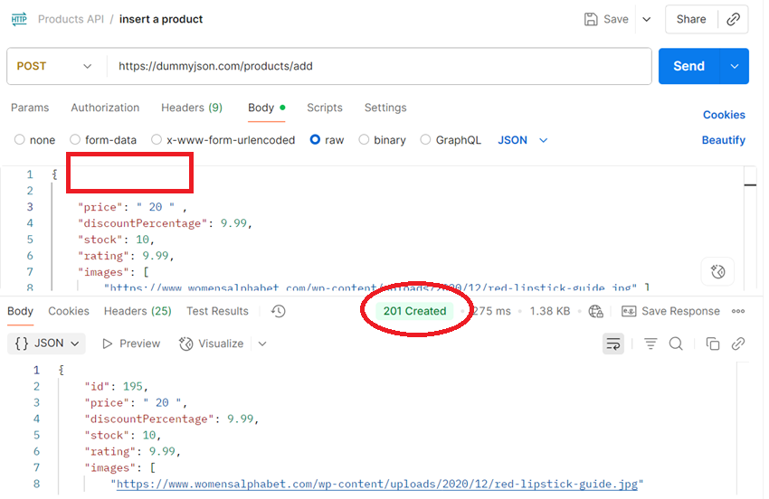

- Steps to reproduce:
- I open Postman and prepare a POST request
- In the JSON body, I fill out all required fields except the name and price fields ( I either leave it empty or remove it completely
- I click Send
- Expected behavior:
Creating a product without name or price should not be allowed. The API shoud response with an error such as “400 Bad Request” etc.
- Actual behavior:
The API returns a “201 Created” response and allows me to create a product without name or price.
- Version:

- Severity: 5
Because releasing a product without all required information (such as name or price) can cause major issues.
- Priority: 5

Bug: Double creating a product
- Description:
When I send a POST request in Postman with a JSON body containing information of an already existing product, the API responds with 201 Created and allows the creation of a duplicate product with the same ID.
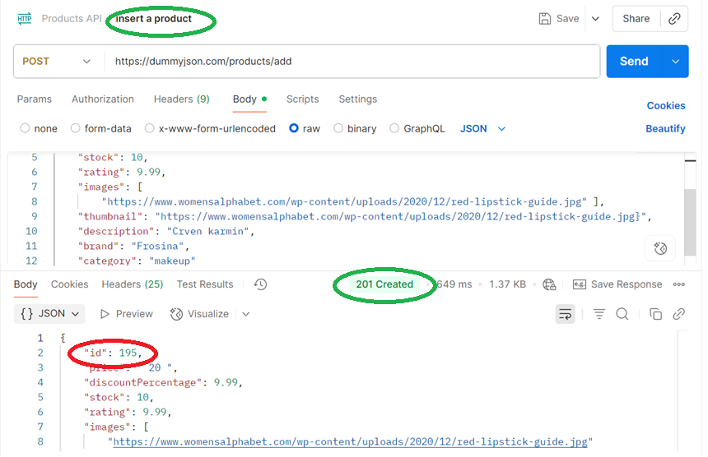

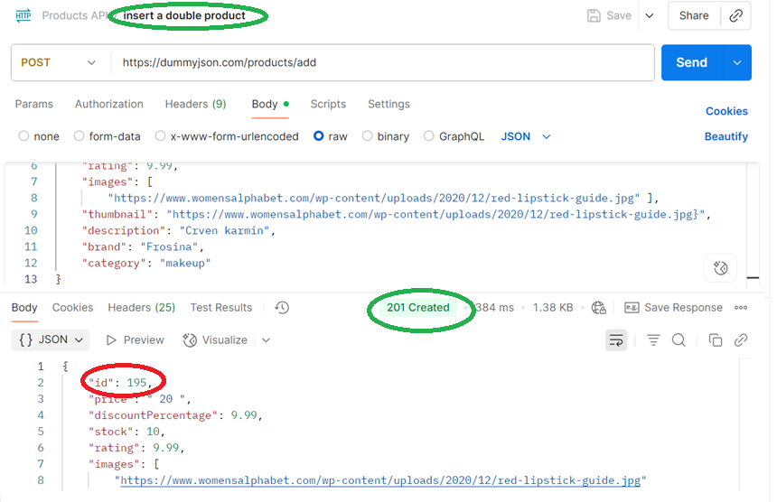
- Steps to reproduce:
- I open Postman and prepare a POST request
- In the JSON body, I fill out all required fields with values of an already existing product.
- I click Send
- Expected behavior:
The system should prevent creating duplicate products and the API should response with an error if the same ID already exist.
- Actual behavior:
The API allows me to create duplicate product and responds with “201 Created”.
- Version:

- Severity: 5
Duplicate products can lead to disruptions in company operations, especially in areas like ordering, product availability, and overall data consistency.

- Priority: 5

